**Kali Linux Basic Commands**

1. Date Command

The **'date'** command is used to display the **system date** and **time.**

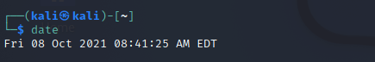

2. Cal Command

The cal command displays the current **month's formatted calendar** on our terminal screen.

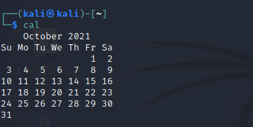

3. Cd Command

The **'cd'** command is also called **chdir** (Change Directory). We used this command to **change** or **switch** the current working directory.

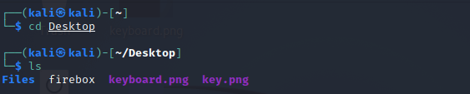

4. cp Command

In Kali Linux, the **'cp'** command is used to **copy** files or a group of files or directories that create an exact image of a file on a disk with a different file name.

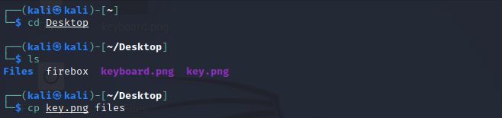

5. whoami Command

The **'whoami'** command is used to print the effective **user ID** whereas the **who** command prints information regarding users who are presently logged in.

The **"w"** command can also be used to view who is logged on and what they are doing.

### Kali Linux Basic Commands

### 6. Ls Command

The **ls** command lists the directory contents of files and directories.

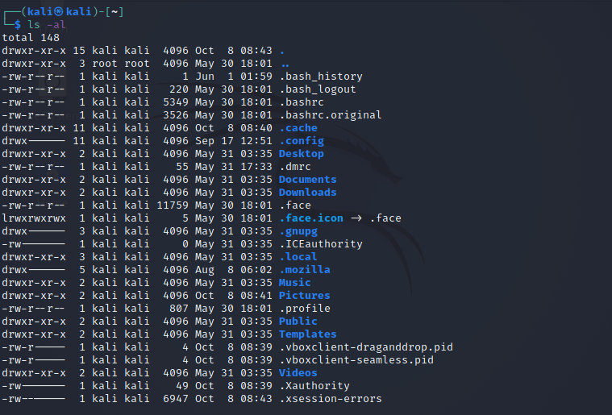

7. Cat Command

The **'cat'** (concatenate) command is one of Kali Linux's most commonly used commands, permitting us to create single or many files, concatenate files and redirect, view contain of file output in terminal or files.

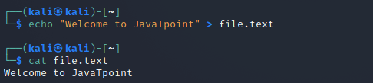

8. mkdir Command

The **'mkdir'** command is used to **create directories.** For example, if we wish to create a directory named **'Penetration testing'** under the **'Documents'** directory, then we have to open a terminal and enter the below command:

1. cd Documents
2. mkdir Penetration testing

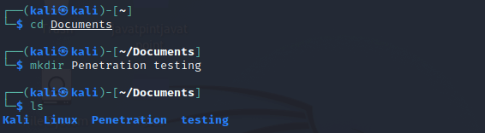

9. rm Command

In Kali Linux, the **'rm'** command is used to **delete files.** It can be used to delete directories when we use them recursively.

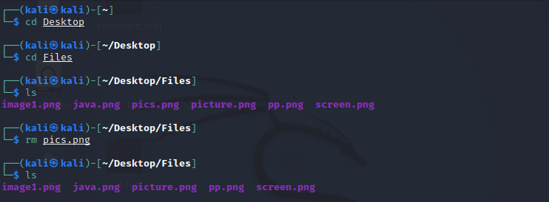

10. mv Command

With the help of the **'mv'** command, we can **move** or **renames** files and directories on our file system.

### Kali Linux Basic Commands

### 11. uname Command

The **'uname'** command displays the **current system's information.** We can view system information about our Linux environment with the uname command in Linux. With the **uname -a command,** we can learn more about our system, including **Kernel Name, Node Name, Kernel Release, Kernel Version, Hardware Platform, Processor,** and **Operating System.**

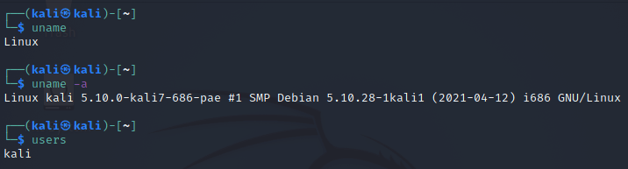

12. uptime Command

The **'uptime'** command displays the amount of time the system has been running. Uptime's basic usage is simple: simply **type** the name of the command and click **Enter.**

Use the **-p** command-line option if we merely want to know how long the system has been up for and in a more human-readable format.

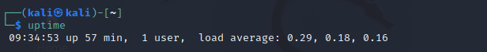

13. users Command

The **'users'** command is used to display the **login names** of users logged in on the system.

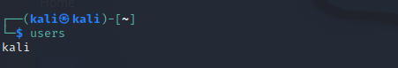

14. less Command

In Kali Linux, the **'less'** command is used to view files instead of opening the file. The less command is a more powerful variant of the **"more"** command which is used to show information one page at a time to the terminal.

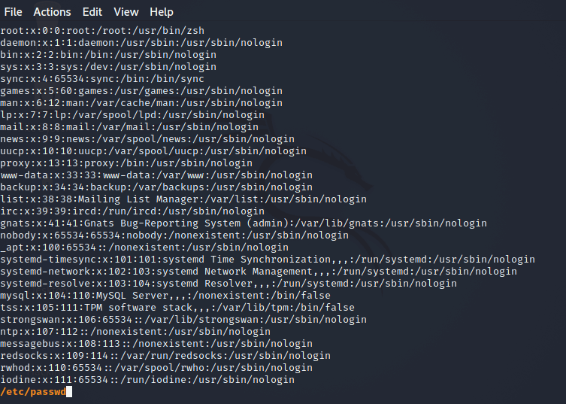

15. more Command

The **"more"** command permits us to show output in the terminal one page at a time. This is particularly beneficial when using a command that requires a lot of scrolling, such as the '**ls'** command or the **'du'** commands.

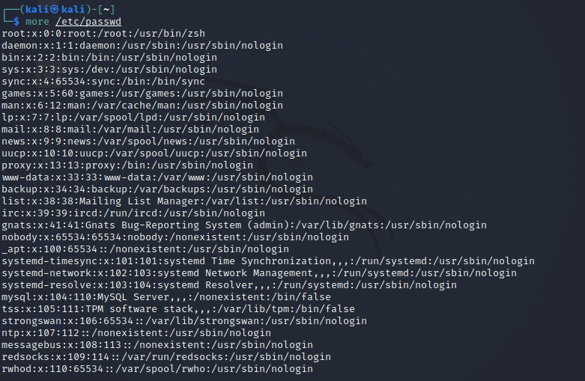

16. vi Command

The **'vi'** editor is a screen editor that comes with practically every **UNIX** system. The **command mode** and the **insert mode** are the two most common nodes in vi.

In order to start entering text in an empty file, we have to first switch from the command mode to the insert mode. Type some short lines, then press Return at the end of each.  If we make a mistake, we can undo it by pressing the **Backspace** key.

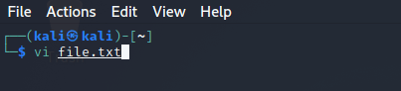  
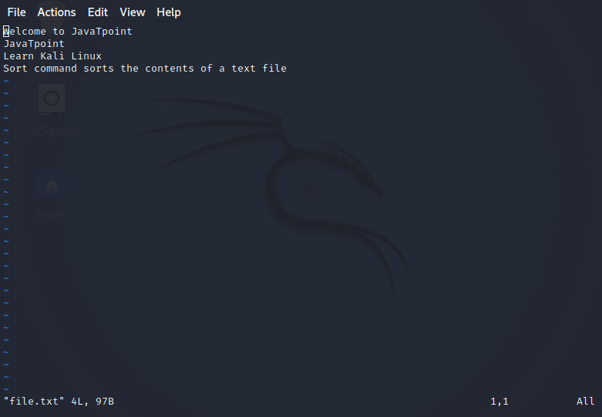

### 17. free Command

In Kali Linux, the **'free'** command provides us the useful information about the **amount of RAM** available on a Linux machine. It also displays the entire amount of **physical memory** used and available space, as well as **swap memory** with **kernel buffers.** If we use the **free** command with the **-t** option, it would list the total line at the end.

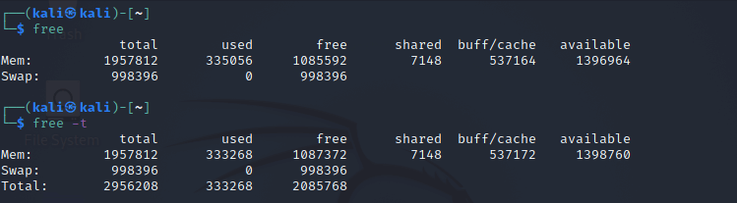

## **18. sort Command**

Using the **'sort'** command, we can sort the content of the text file, line by line.

We can reverse the order of any file's contents by using the **-r** sort.

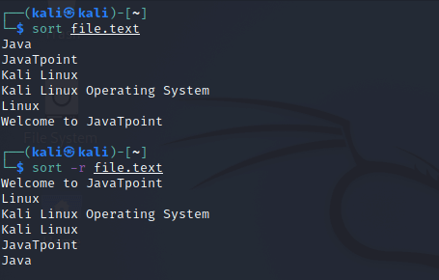

### 19. history Command

The **'history'** command is one of Kali Linux's most commonly used commands. The history command in the bash shell saves a history of commands entered that can be used to repeat commands.

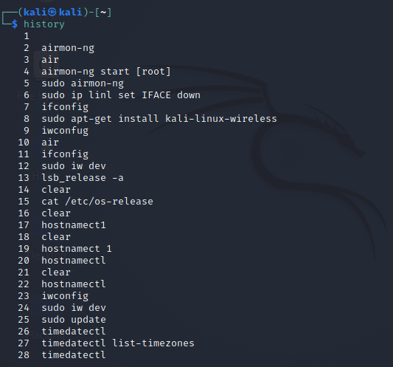

### 20. Pwd Command

In Kali Linux, the **'Pwd'** command is used to **print working directory.** It gives us information about the directory we are now in.

